Chiefs of Ontario
Fall Chiefs Assembly
November 21-23, 2023 Toronto, Ontario

BRIEFING NOTE
Restructure of First Nations Lifelong Learning Table
To: Chiefs in Assembly
From: COO Education Sector
Date: November 1, 2023
Purpose: Decision-making

ISSUE

A resolution will be brought to the Chiefs in Assembly to confirm a path forward to improve the working relationship between First Nations in Ontario and the Ministry of Education and inform future work of the First Nation Lifelong Learning Table (FNLLT) with recently gathered data driven evidence.

BACKGROUND

Resolution 45/16 Provincial Bilateral Process on Education approves the Terms of Reference for the First Nations Lifelong Learning Table (FNLLT), which is the bilateral process between First Nations in Ontario and the Ministry of Education established in 2017.
The FNLLT is a sub-committee of the Chiefs and Technical Committee on Language and Learning (CTCLL). The FNLLT was established to provide a forum for First Nations in Ontario and the Ministry of Education (EDU) to identify, prioritize, discuss and advocate to address issues and opportunities related to the educational needs of First Nations learners in the provincial education system.
The FNLLT, when established in 2017, consisted of three components:
- Steering Committee (comprised of the Minister and Deputy Minister of Education, the Ontario Regional Chief and the COO Chiefs Committee on Lifelong Learning)
- Central Policy and Planning Circle (comprised of technical representatives of the First Nations Education Coordination Unit, the Chiefs of Ontario Education Sector, and the Ministry of Education)
- Coordinators (representing Association of Iroquois & Allied Indians, Nishnawbe-Aski Nation, Anishinabek Nation, Grand Council Treaty #3, Independent First Nations and the COO Secretariat)
Since the establishment of the FNLLT in 2017 the technical, political and social landscape has shifted causing disruption to effective communication between First Nations in Ontario and the Ministry of Education. The deterioration of effective communication also resulted in a decline in effective engagement processes all resulting in a need to update, reset and restructure the bilateral process.
The Education Sector at the Chiefs of Ontario Secretariat provided input to the COO Leadership Council to inform discussions at the June 2023 Leadership Advocacy Strategy meeting with provincial leadership. This meeting resulted in a commitment by both parties to simplify and reinvigorate the FNLLT through the establishment of a Planning Circle and sustained provincial participation with the FNLLT Coordinators in a Collaboration Circle to address relationship, communication and engagement challenges.
The Planning Circle convened their first meeting on September 18, 2023 and are now embarking on reaffirming priority areas of focus and developing recommendations for the FNLLT Terms of Reference. The Collaboration Circle continues to engage with First Nation communities and designated entities to address previously established priority areas.
ANALYSIS

- The evolution of the FNLLT has not kept up with the ever-changing technical, political and social landscape. Diligent and sustained attention is required to ensure the structure and function of the FNLLT is adjusted to meet the needs of both partners and most importantly the First Nations in Ontario.
- Recent reports developed within the COO Education Sector provide evidence that there are significant systemic gaps in outcomes for First Nations learners attending provincial schools (see attached reports Student Outcomes in Provincially Funded Schools and Suspensions, and Equitable Access to a Positive Disciplinary Climate and Significant Outcomes of Recent Analyses in Appendix B) that require immediate attention.

CURRENT STATUS

The FNLLT has been restructured as indicated in Appendix A and requires a renewed mandate from the Chiefs in Assembly to reaffirm existing priority areas, establish new priorities and focus on addressing systemic gaps as evidenced in recent reports.

RECOMMENDATIONS

The Chiefs in Assembly consider approving the draft resolution on the First Nations Lifelong Learning Table.

ATTACHMENTS

- Student Outcomes in Provincially Funded Schools
- Suspensions, and Equitable Access to a Positive Disciplinary Climate
Appendix A

FNLLT Structure 2017

FNLLT Structure 2023
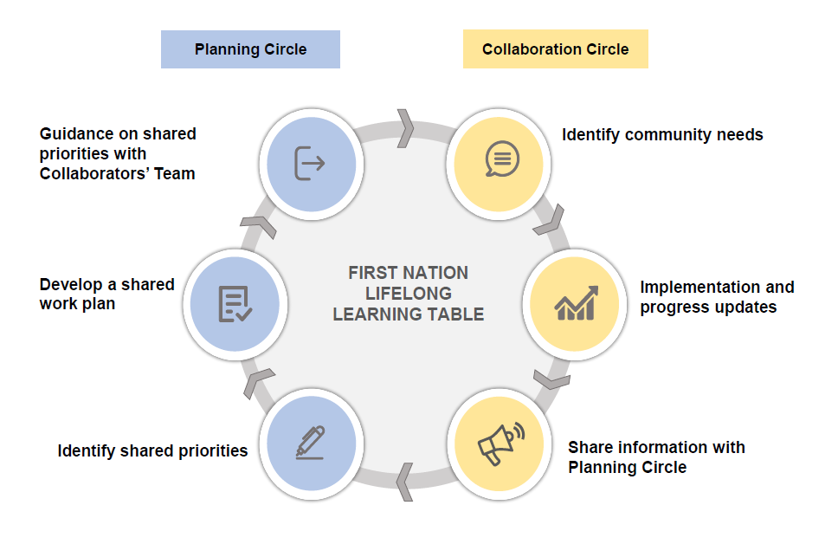

Appendix B

Significant Outcomes of Recent Analyses

Student Outcomes in Provincially Funded Schools
- Attendance
  - In 2018-19 67% of Ontario students attended school at least 90% of the time, compared to 40% of First Nations overall and 24% of students living in First Nation communities.
- Grade 9 Credit Accumulation
  - In 2019-20, 68% of First Nations students were “on track” for graduation with 8 credits earned in grade 9, compared to 87% of Ontario students overall.
  - In 2018-19 First Nations students were heavily overrepresented in applied math, associated with lower chances of graduation and postsecondary.
- Graduation in Four and Five Years
  - Between 2016-2017 and 2020-2021 89% of Ontario students graduated with an Ontario Secondary School Diploma (OSSD) within five years, among First Nations students only 60% did.
  - A larger proportion of First Nations graduates (9%) take five years to graduate than the Ontario average (5%).
  - Self-identified First Nations students are three times more likely than the Ontario average to finish high school with a Certificate (OSSC) instead of an OSSD (3% vs. 1%). A certificate represents partial completion of diploma requirements.

Suspensions, and Equitable Access to a Positive Disciplinary Climate
- Suspensions in Elementary Schools
- In 2018-19, 9.4% of First Nations students in elementary school faced suspension, compared to 2% of Ontario students.
- Suspensions in Secondary Schools
- In 2018-19 the rate of suspension for First Nations students in Ontario was 12.3%, compared to a provincial average of 5.5%.
  - The rate of suspension for students living in First Nation communities was 12.6%.

